Task 9 - Select students who does not pass any exam using each the following operator:  
-- Outer join  
-- Subquery with ‘not in’ clause  
-- Subquery with ‘any ‘ clause  
-- Check which approach is faster for 1000, 10K, 100K exams and 10, 1K, 100K students

Performance tests:

For 1000 exams and 10 students  
-- Outer join  
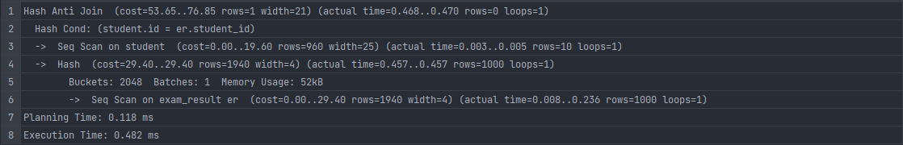 -- Subquery with ‘not in’ clause  
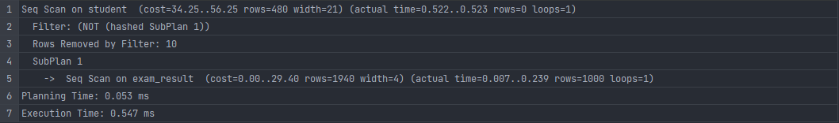 -- Subquery with ‘any ‘ clause  
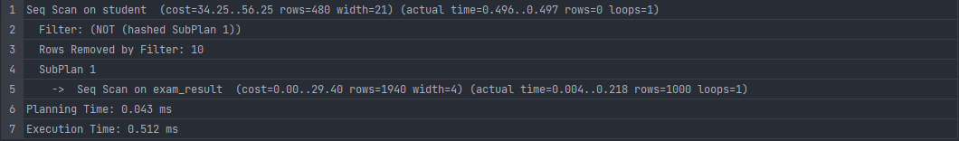

For 10K exams and 1K students  
-- Outer join  
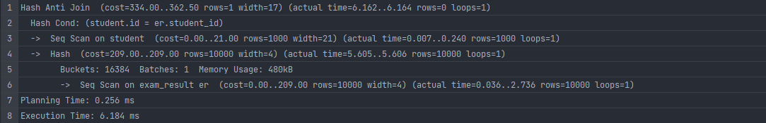 -- Subquery with ‘not in’ clause  
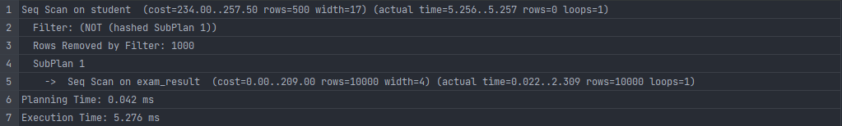 -- Subquery with ‘any ‘ clause  
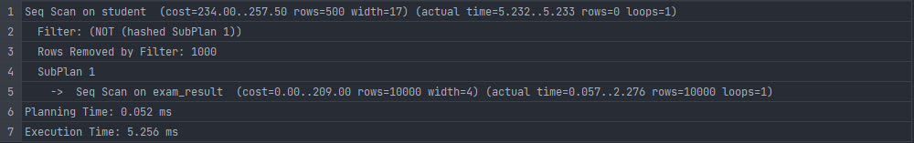

For 100K exams and 100K students  
-- Outer join  
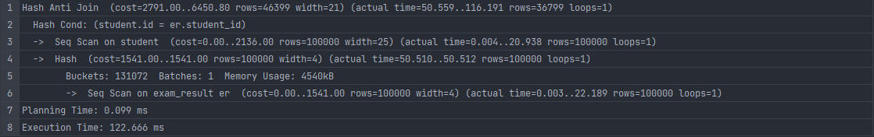 -- Subquery with ‘not in’ clause  
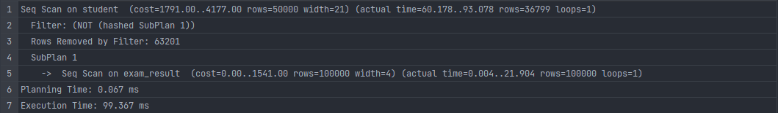 -- Subquery with ‘any ‘ clause  
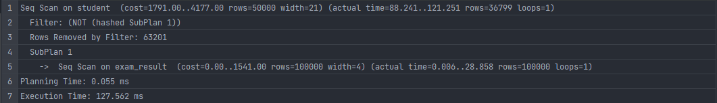

In all tests outer join works slower than ‘NOT IN’ and ‘ANY’. Moreover, ‘NOT IN’ and ‘ANY’ approaches have similar values.